# Denmark – Script Instruction

**URL:** <https://www.retsinformation.dk/>

Go to [advanced search feature](https://www.retsinformation.dk/extremesearch?d=true&o=40&p=1&ps=10&q=%7B%22type%22%3A%22group%22%2C%22id%22%3A%220985DB6C-9E5B-430F-9BA6-DEAAD7CD0091%22%2C%22children1%22%3A%7B%2255434E1C-8DD2-4C46-9082-813902814890%22%3A%7B%22type%22%3A%22rule%22%2C%22properties%22%3A%7B%22field%22%3Anull%2C%22operator%22%3Anull%2C%22value%22%3A%5B%5D%2C%22valueSrc%22%3A%5B%5D%7D%7D%7D%2C%22properties%22%3A%7B%22conjunction%22%3A%22AND%22%7D%7D) and apply the following instructions. For easier navigation of the instruction, set the web language to English.

1. In “Select search area” dropdown menu, select “Rules”.

1. After selecting “Rules”, multiple filters will appear. Retain 3 filters and delete the rest by clicking the trash icon indicated below.

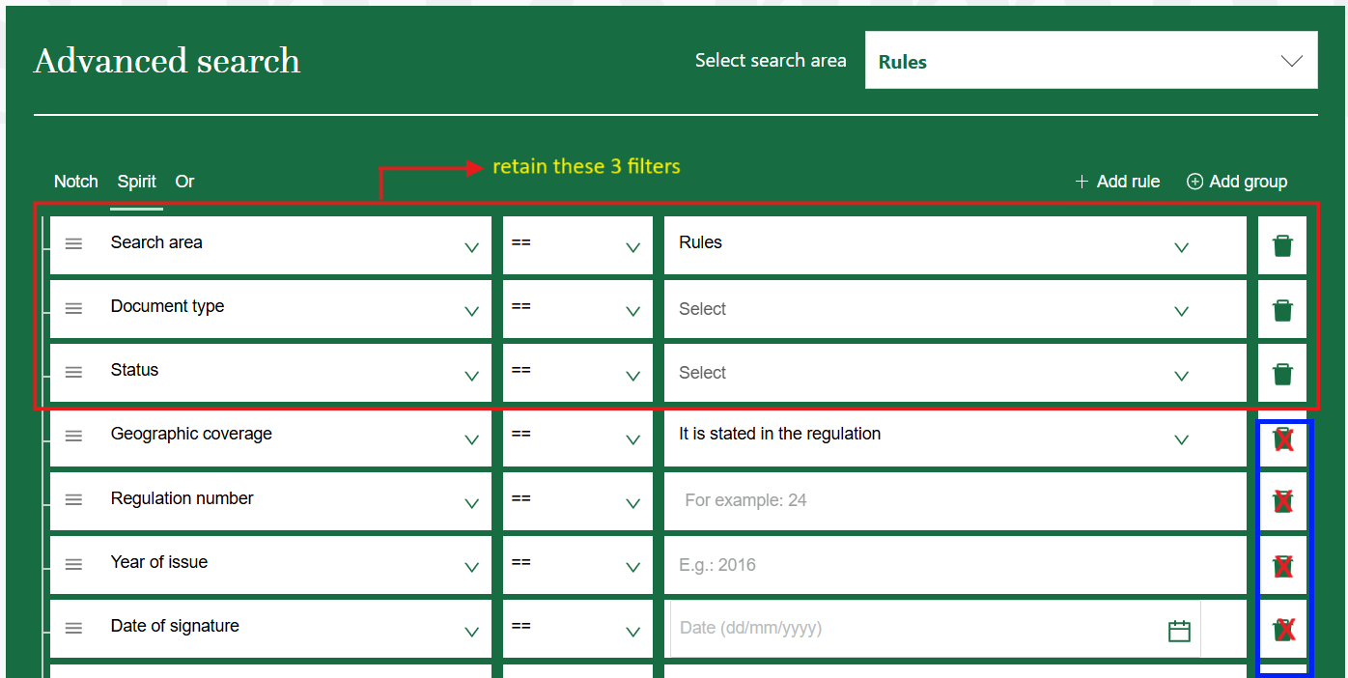

1. In the first filter, ensure that the search area is set to Rules.
2. In the second filter, change the “Document type” dropdown to “Title”. Then the next column dropdown should be “Phrase search”. In the next column is where the keywords to be entered.
3. In the third filter, change the “Status” dropdown to “Document type”. Set the document type to the following types of regulations. Note: One type can be selected at a time.

* Law – In the output, any legislations in this type should be captured as “Act”.

* Legislative Decree – browser’s built-in Google Translate sometimes provides misleading translations. This should be “Consolidated Act” (Lovbekendtgørelse). Please ensure that Consolidated Act is captured in the output instead of Legislative Decree.



* Announcement – browser’s built-in Google Translate sometimes provides misleading translations. This should be “Executive Order” (Bekendtgørelse). Please ensure that Executive Order is captured in the output instead of Announcement.

* Executive Order (International)

* Circular (1 cr) and Circular (2 credits)

* Guidance

1. The final filter should look like this:

Enter the Danish keywords into the search field of the second filter without quotation marks, then click the Search button. Please refer to the list of keywords.

For example, entering “Beskyttelse af whistleblowere” returns 1 result in Law document type. After extracting the metadata of this result, proceed to the next document type as stated above.

## Extraction of Metadata

On the list of search results, open each piece of legislation. Ensure that the language is set back to Danish. When already on the legislation page, click “Yderligere oplysninger” (Additional information) which is circled in the screenshot below, to extract the complete metadata indicated by color boxes in the screenshot after the bullet items as follows.

* Source link – the URL of the legislation page.
* Original title – the complete title displayed on the page, labeled in red.
* Type of regulation – inferred from the Document type, labeled in green.
* Date of adoption – inferred from the Dato for underskrift (Date of signature), labeled in blue.
* Entry into force date – this is found within the body of the text, in a section explicitly titled “Ikrafttræden” or “Ikrafttrædelse” (Entry into force), labeled in purple below. Just search any of those two phrases.

### Additional notes in extracting the metadata

**Original Title** – Do not capture the footnote reference appearing in the title.

**Type of Regulation** – Use the English term in the scraped output.

1. Lov (Act)
2. Lovbekendtgørelse (Consolidated Act)
3. Bekendtgørelse (Executive Order)
4. Bekendtgørelse (international) (Executive Order (International))
5. Cirkulære (Circular)
6. Vejledning (Guidance)

**Entry into Force Date** – If the section “Ikrafttræden” or “Ikrafttrædelse” (Entry into force) does not specify a date, leave the entry into force field blank. For example, in the [Climate Act](https://www.retsinformation.dk/eli/lta/2020/965), no date is provided under the Entry into force section.

Also, if a particular legislation does not explicitly mention a section “Ikrafttræden” or “Ikrafttrædelse” (Entry into force), leave this information blank.

## Important Reminders

1. Duplicate titles and/or source links should be removed and retain one copy of each duplicate.
2. Follow this date format for consistency – yyyy-mm-dd.
3. For non-English, please translate all the type of regulation column into English:

* Lov (Act)
* Lovbekendtgørelse (Consolidated Act)
* Bekendtgørelse (Executive Order)
* Bekendtgørelse (international) (Executive Order (International))
* Cirkulære (Circular)
* Vejledning (Guidance)

1. Add one column beside the Original Title and translate the titles into English.
2. Please exclude any legislations containing the following Danish terms in the title:

* ændringsforslag (amendment)
* ændring (amending)
* at ændre (to amend, to change, to alter)
* bevilling (appropriation)
* budget (budget)
* ophævet (repealed)
* ophævelse (repealing)
* tilbagekaldt (revoked)
* lufthavn (airport)
* flyselskab (airline)
* udnævnelse (appointment)
* udnævnt (appointed)
* patient (patient)
* coronavirus / COVID-19

For any queries, issues, or clarifications regarding these instructions, kindly post them promptly on our Teams channel so we can provide a timely response or action as needed.

[ESG KLI Project | ESG KLI Project | Microsoft Teams](https://teams.microsoft.com/l/channel/19%3A2cb71aBrx0vDiOIeb2XNrxxCN2EoVFDjq_GOAxRevDY1%40thread.tacv2/ESG%20KLI%20Project?groupId=6f8eb5d6-d2c9-4fe4-a2b2-16b14d6fcc9a&tenantId=be92c534-7b60-4630-bc01-ec5122548d47)